Japan’s Silver century

Shaping a Prosperous and Healthy Ageing

Henry Bojia Zhang z536305

Executive Summary
This report addresses the complex financial challenges arising from Japan's demographic shift towards an ageing society. Focused on pension management in the context of an ageing population, the analysis delves into constructing a resilient portfolio to secure financial futures amidst prolonged retirement aspirations. This report constructed a diversified portfolio of 25 Tokyo Stock Exchange listed stocks, 5 Vietnamese listed Stocks and Japan’s 3-month Government Bond and used their historical data to assess a variety of risks, impacts of diversification, sectoral restrictions and used that information to regress a security market line as a baseline for future exploration and improvements on this portfolio.

The Market and Stock Selection

Composition
According to the Efficient Market Hypothesis, publicly available information will be captured in the prices changes of assets in the market. As such, it is unreasonable to rely on Active Management Strategies. Therefore, the primary strategy in stock selection was to select a diverse portfolio that would reflect the state of the market to mirror the efficient portfolio deemed by the market.
An important assumption made during stock selection was that the primary portfolio for analysis was not going to have the ability short sell. This is in part because the final portfolio being combined with the stock would be analysed under the condition of no short sells. Another reason can be attributed to the fact that short selling has many practical issues, as it can potentially produce unlimited losses if the value of the asset skyrockets and is unreliable long term as it is unreasonable to assume that a company would allow its returns to keep dropping and stay negative over a period of 10 years like our dataset. Therefore, the stocks chosen were all high performing stocks with various risk-levels in a variety of sectors to increase the diversification of the portfolio.

Tokyo Stock Exchange (TSE)
Historic data from 2015-22 was used to evaluate the average sector weights in the Nikkei Stock Average (N225) and forecast future trends (Siblis Research, 2020). Figure 1.1 provided an approximate draft for the proportions of each sector for the portfolio for this paper. Figure 1.2 suggests a growth in the Information Technology Sector in the future proceeding to the future. Additional statistics indicate industrial machinery and IT electronics equipment are fast growing industries with high potential (Cissoko & Company, 2023). Historic returns were used to identify potential selections in each sector. The primary statistic used to measure the performance of a stock as through their average return, average variance, and the coefficient of variation. Accounting ratios were used to further pinpoint the ideal stock candidates for this portfolio.
The first stocks selected to be included in the portfolio consisted of companies with impressive reputations that also historically performed well (TradingView). Many of these stocks were selected based on their consistent performance historically (Figure 1.3). In addition to this, many of these companies belonged to some of the biggest industries in Japan such as electronics, automotives, and manufacturing to name a few (Sawe, 2018), in conjunction with their low coefficient of variation, these companies were statistically a safer set of stocks to invest in. This included, but weren’t limited to:
- Toyota which had the lowest historic standard deviation of all automotive stocks provided in the dataset. Toyota’s presence as a market leader in Japan which is a global leader in the automotive industry in addition to its strong brand presence and historic performance make this a safe choice, especially in the long term. Furthermore, the recovery of the automotive market following the global pandemic in addition to increased demand in electric vehicles provide optimistic outlooks for the automotive market in general.
- McDonalds was included as part of this portfolio due to similar reasons to Toyota, as it possesses a strong brand presence and good historic performance. McDonalds also possessed the lowest average standard deviation at 0.18%. McDonalds also has a very healthy long-term financial ratios with a D/E ratio of 23% compared to an industry standard of 75.35% (Investing.com).
- Sony Group Corporation has seen explosive growth over the past decade. In the electronics market alone, not only has Sony has become a powerhouse with electronics in audio, displays, and cameras, but Sony has expanded a variety of industries including music, entertainment, and finance.
- Nintendo is a similar stock to Sony, in that it has established history of consistent returns, and more recently Nintendo has seen success expanding into the film industry and still has the potential to grow in a similar manner to how Sony has.
The stocks considered secondarily for this portfolio were assets from emerging industries and recovering industries that have shown high volatility historical but equipped with the potential for high returns. The primary indicator used to compare these companies was how good their historic returns were in addition to verifying the financial health of through accounting ratios. These included, but weren’t limited to:
- Tokyo Electron saw an overwhelming price drop in 2023 following semiconductor sanctions Japan issued to China (Castellano R, 2023). This is reflected this financial year’s EPS ratio dropping to a low of 5.2 compared to the industry’s 24.56 (Macrotrends), but historic EPS growth was on par with the industry standard (Investing.com). Furthermore, increased demand in semiconductor technology (Cissoko & Company, 2023) and recovery of the semiconductor market after the drop suggest high potential for investing in Tokyo Electron. Furthermore, Tokyo Electron’s other accounting ratios are better than the industry average over the past 5 years, including their P/E ratio of 21.96 compared to 23.91 and a ROE of 30.18 against the industry’s 20.76.
- Chugai Pharmaceutical is one of Japan’s leading pharmaceutical companies. As the brief provided, Japan currently possesses an ageing population, pharmaceuticals and healthcare will become ever-so relevant to the Japanese economy as its demand will increase with ageing population. Furthermore, its Financial Ratios are extremely healthy, such as a P/E ratio of 22.73 against 29.84, ROE of 23.36% compared to 10.33%, Quick Ratio of 3.54 to 2.22 and Current Ratio of 4.76 to 2.92 (Investing.com). Chugai Pharmaceutical’s financial health prepares it for the inevitable ageing of Japan’s population.
- Oriental Land which is a tourism company most prominently known for their management of Disneyland Tokyo. Following the end of the global pandemic, tourism in Japan has recovered with overwhelming vigour (Euroview, 2023). The recovery of the tourism industry will undoubtedly set Oriental Land as a stock with high potential.
Any remaining stocks were then selected by comparing the distribution of already chosen stocks by sector and selecting stocks from unexplored sectors that would help increase the diversification of the portfolio and hence decrease unsystematic risk. Reasons for the remaining stocks are attached in the appendix. The resultant portfolio had a final distribution according to Figure 1.4 which is like the market distribution.

Ho Chi Minh Stock Exchange (HOSE)
The 5 stocks chosen were selected as an auxiliary. That is, they were selected to make up for any shortcomings of the 25 Japanese stocks chosen. This meant choosing stocks that belonged to sectors and/or industries that were underinvested in or overlooked. These included:
- VinaMilk is a leading dairy company in Vietnam. It has potential for growth in the emerging market of dairy products. Furthermore, it will hopefully increase the diversification by having a company in consumer staple sector as the original portfolio had little assets belonging to Consumer Staples.
- Viet Nam Joint Stock Commercial Bank Positioned in the growing Vietnamese financial sector. Major bank in Vietnam with a diverse range of financial services. It has extremely good long-term financial health, with D/E ratio of 23.35% compared to an industry average of 102.66% in and their other ratios are about industry standard as well (Investing.com).
- National Seed Co is engaged in the production and distribution of seeds for farming. Since none of the chosen stocks included any assets in agriculture, National Seed Co was included as it is a leader in agricultural investments and products in Vietnam.
- Dry Cell and Storage Battery Co is involved with the production of dry cells and batteries. As Vietnam’s economy and it begin relying on IT solutions and technology, Dry Cell and Storage Battery Co will be positioned in the Vietnamese market to meet that demand.
- Ha Do Group Co is a real estate development and construction in Vietnam. It is positioned to target the Vietnam’s growing real estate market. Furthermore, it has one of the stocks with lower risks in Vietnamese stocks.

Methodology
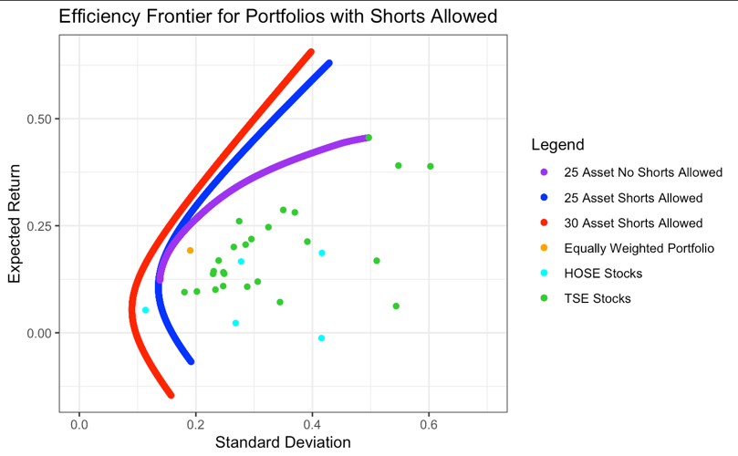
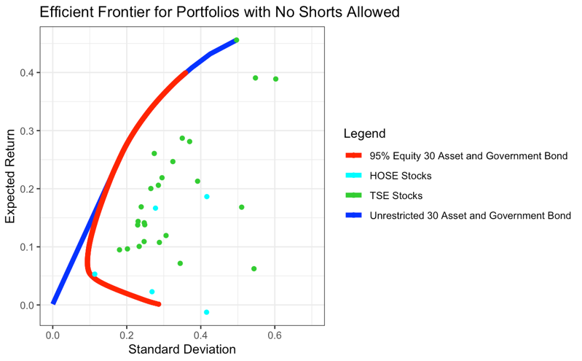
Every analysis was performed using R in RStudio. Functions were created used calculate weekly continuously compounded returns, annual expected returns, standard deviation, and covariance for each asset. The IntroCompFinR package in R was used to calculate the minimum variance portfolios for a variety of scenarios. Any portfolios with additional restrictions were solved using the functions from the quadprog package (Zivot, 2019). The final graphs used in the report were constructed through the ggplot2 package. All results are presented in the appendix.
Figure B
Figure A

Key Findings and Results
Figure A demonstrates the risk-return relationship of a variety of portfolios and assets. For the shorts allowed portfolios, it is evident that no TSE or HOSE stocks lie on either unrestricted efficient frontier, indicating that none of the chosen stocks are mean-variance efficient. Furthermore, the addition of 5 HOSE assets to the 25 TSE stocks has shifted the entire efficient frontier left which indicates a decrease in standard deviation for the same expected return. This agrees with intuition, where the addition of Vietnamese Stocks has increased the diversification of our portfolio, which has decreased the unsystematic risk. Compared to the efficient portfolio with an expected return reduction for a 15% return portfolio, 3.05% risk was eliminated. Also, for an equally weighted portfolio of the 25 TSE stocks, theory states that it should lie inside the minimum variance frontier and Figure A undoubtedly demonstrates that. An efficient frontier was also constructed with the restriction that the weights for Technology and Electronics could only make up at most 10% equity (Figure 2.4). It was identical.

Weight Distribution of Japanese only Portfolio
Another portfolio analysed was the 25 asset TSE portfolio with no shorts sales allowed. From Figure A, we can see that both efficient frontiers share the same global minimum variance portfolio, but for efficient portfolios with higher expected returns, the corresponding risk growths exponentially. That is, the least increase in risk appears at the global minimum variance portfolio and the increases in risk increase the higher expected return a portfolio has. Comparing the weights two portfolios with the same expected return of 15%, where one can short assets and the other cannot, we find that weights that were originally negative and being shorted are now 0. This is self-explanatory, as any stocks originally shorted were expected to have negative or extremely low returns compared to the rest of the portfolio. Therefore, if we weren’t allowed to short those stocks, we would prefer to not have them in the portfolio at all. Examining Figure 2.5 it is evident to see a pattern in how the weights of the TSE assets changed when a short sale restriction was added. It is possible to see 3 clear clusters, where the weights for two high performing stocks increased, with weights for moderately performing stocks remaining approximately constant and the less mean-variance efficient assets decreasing in weight. In a portfolio with shorts sales, the ability to short allows us to also invest in poorly performing stocks with negative weights, while simultaneously allowing us to allocate more weight to the other well performing stocks. The portfolio therefore compensates the restriction of short sales by increasing the weights of stocks with high expected returns. This explains why for higher expected returns, the efficient frontier of 25 asset no short portfolios become riskier compared to the shorts allowed counterpart, as we are unable to mitigate risk through diversification in the shorted stocks and must increase the weights of high-risk high return stocks.
The ramifications of this for our actual portfolio are simple, if portfolio cannot short assets, then the higher the target return of our portfolio, the higher risk the portfolio will have compared the global minimum variance portfolio. As such, it will be necessary to deeply consider the ability and conditions of whether our portfolio will be able to short assets, especially considering differences in legality in foreign countries.

Weight Distribution of Japanese Portfolio in addition to 3-Month Japanese Government Bonds (JGB)
When the 3-month Japanese Government Bonds were included as a riskless asset in the prior portfolio, the resultant portfolio was analysed under the restriction of no shorts allowed (Figure 2.7). Immediately, the efficient frontier does not match the theoretical linear shape of a portfolio with a risk-free asset, which should be linear. This can be attributed to the effect of restricting shorts on a portfolio that exponential increases the gain in risk as the expected return increases. While the inclusion of a risk-free asset has been able to create a relatively linear shape, after a particular threshold, the effect of the restricting short sales can be seen in the bend in the curve. This suggests that in markets where we cannot short assets, even the inclusion of a risk-free asset cannot completely offset the increase in risk that comes about of short sale restrictions.
A portfolio with a requirement of 95% in equity was also used to construct an efficient frontier (Figure B). Efficient portfolios with this restriction are the same for higher expected returns. However, as the target expected return decreases, the efficient frontier curves more to the right compared its unrestricted counterpart. In actual application of this portfolio in the market, this would be an important condition to consider. In real world applications, there doesn’t exist truly risk-free assets, and investing everything into government bonds may have the ever-so slight chance of catastrophically failing. Therefore, important to maintain diversity in our portfolio, and recognise the effect of limiting equity weight in portfolios with a lower target return. When comparing the weights for these portfolios with a target expected return of 15%, all the weights of stocks used in the unrestricted portfolio increase which is unsurprising. However, one of the Vietnamese stocks that had a weighting of 0, now has the most weight in the restricted portfolio. It is likely that this asset has the highest mean to risk efficiency, allowing the portfolio to reach the 15% target return threshold.

The Japanese Market and its SML
Finally, we examined the Beta coefficients of each Japanese stock and used them to regress a Security Market Line (Figure C). In the resultant diagram, 11 assets are underpriced, and 13 assets are overpriced. In alignment with market theory, the SML is sloping upwards, indicating increasing returns with increased risk and responsiveness to the market. The estimated risk-free rate was found to be 4.45%.

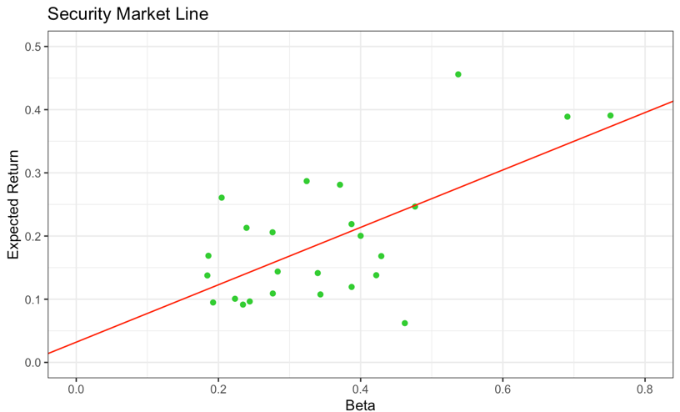
Conclusions

In conclusion, this analysis of hypothetical portfolios establishes a good foundation for further research. This information can be used further re-evaluate stock selection for further analysis or can be a used as reference to evaluate other potential assets for investment.
Figure C

References
- Castellano, R. (2023). Tokyo Electron: World’s Second-Largest Equipment Company Is Oversold (OTCMKTS:TOELY) | Seeking Alpha. [online] seekingalpha.com. Available at: https://seekingalpha.com/article/4630069-tokyo-electron-worlds-second-largest-equipment-company-is-oversold-as-japan-sanctions-on-china-begin [Accessed 9 Nov. 2023].
- Cissoko & Company. (2023). The Fastest-growing Industries in Japanese Market: Why in The Land of The Rising Sun, The Sun is Still Rising? [online] Available at: https://cissokomamady.com/2023/02/16/the-fastest-growing-industries-in-japanese-market-why-in-the-land-of-the-rising-sun-the-sun-is-still-rising/.
- Euronews. (2023). Japan reveals plan to tackle overtourism as visitor numbers soar. [online] Available at: https://www.euronews.com/travel/2023/10/20/new-tourist-tax-and-higher-transport-costs-how-japan-is-planning-to-combat-overtourism [Accessed 10 Nov. 2023].
- Investing.com. (n.d.). Tokyo Electron Ltd. (8035) Financial Ratios. [online] Available at: https://www.investing.com/equities/tokyo-electron-ltd.-ratios [Accessed 9 Nov. 2023].
- Macrotrends (n.d.). Tokyo Electron Debt to Equity Ratio 2010-2023 | TOELY. [online] Available at: https://www.macrotrends.net/stocks/charts/TOELY/tokyo-electron/debt-equity-ratio [Accessed 9 Nov. 2023].
- Sawe, B. (2018). What Are The Biggest Industries In Japan? [online] WorldAtlas. Available at: https://www.worldatlas.com/articles/what-are-the-biggest-industries-in-japan.html.
- Siblis Research. (2020). Nikkei 225 Index Sector Weightings. [online] Available at: https://siblisresearch.com/data/nikkei-225-sector-weights/.
- TradingView. (n.d.). Large Cap (Big Cap) Stocks — Japan. [online] Available at: https://www.tradingview.com/markets/stocks-japan/market-movers-large-cap/ [Accessed 9 Nov. 2023].
- Zivot, E. (2019). 13.4 Quadratic Programming Problems | Introduction to Computational Finance and Financial Econometrics with R. [online] bookdown.org. Available at: https://bookdown.org/compfinezbook/introcompfinr/Quadradic-programming.html [Accessed 9 Nov. 2023].

Appendix

Graphs
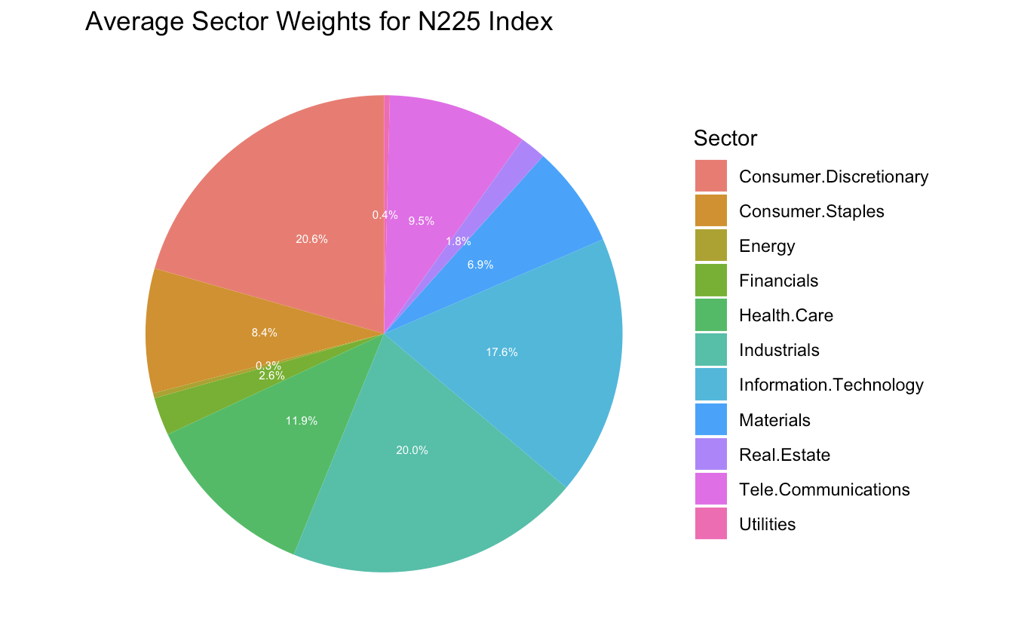
Figure 1.1 Average Sector Weights from 2016-2022 (Siblis Research, 2020)
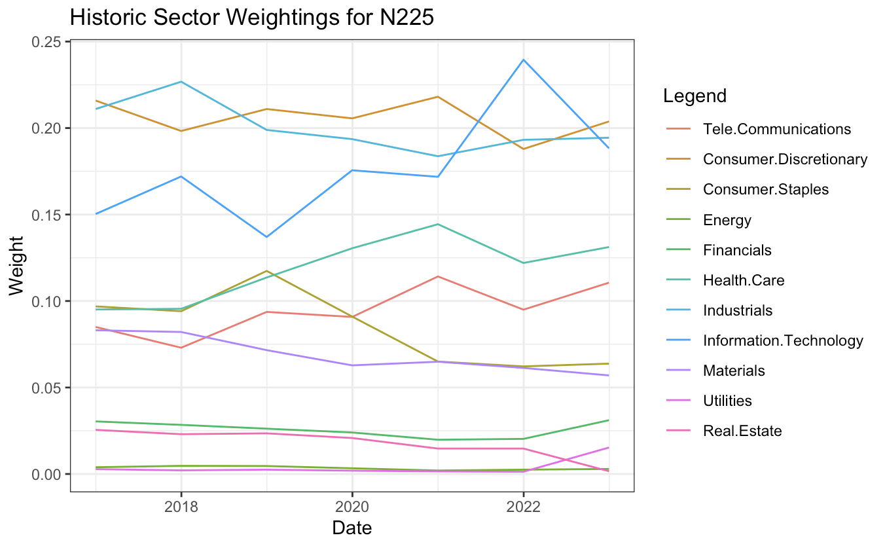
Figure 1.2 Historic Sector Weightings from 2016-2022 (Siblis Research, 2020)
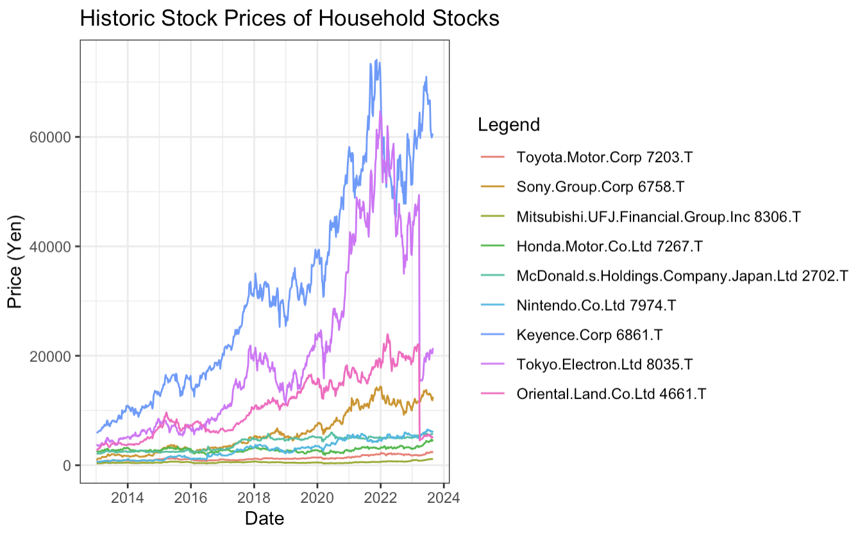
Figure 1.3 Historic Stock Prices of Large-Cap Companies

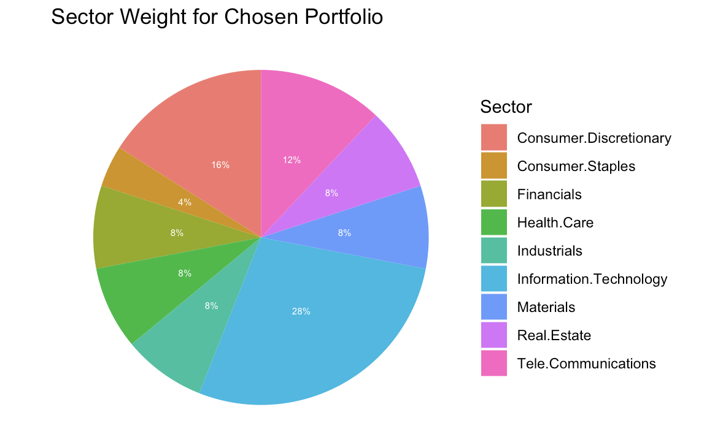
Figure 1.4 Final Sector Weights for Assets from Tokyo Stock Exchange

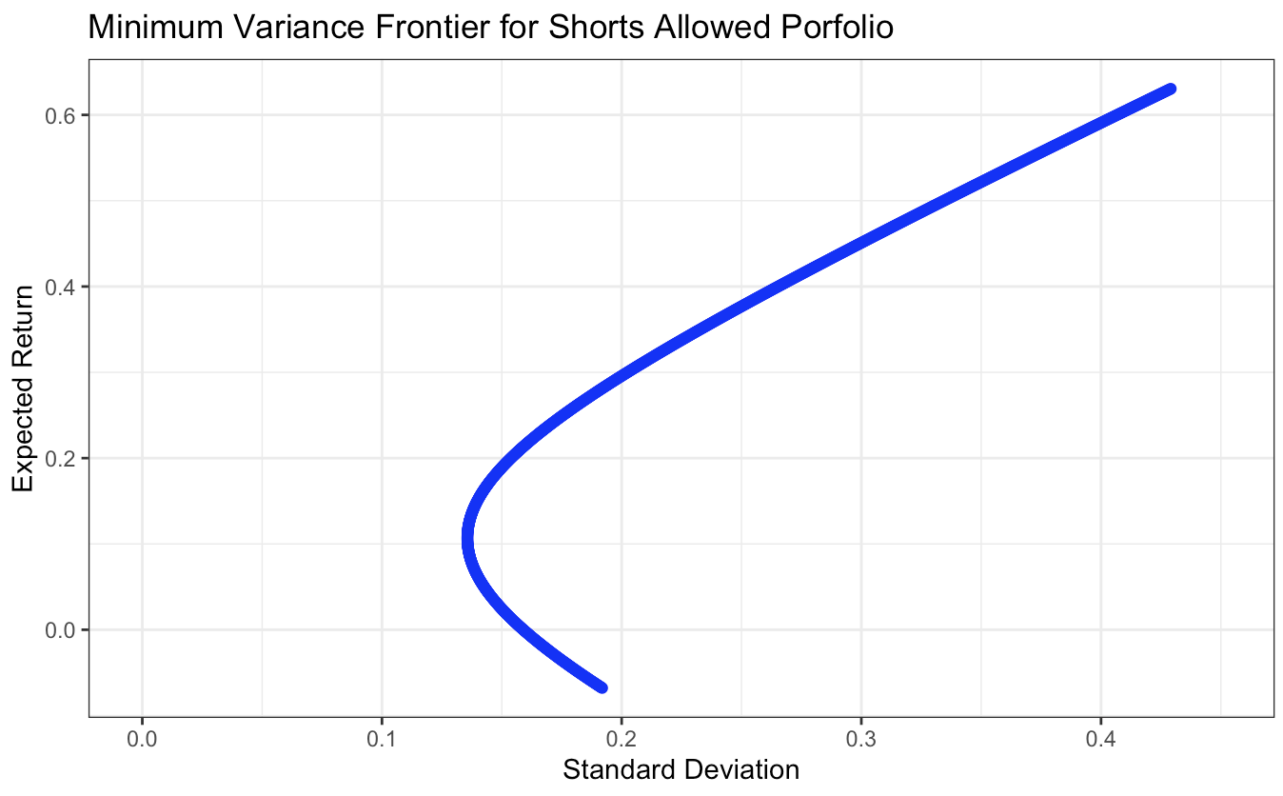
Figure 2.2 Efficient Frontier for 25 Asset TSE Shorts Sale Allowed Portfolio
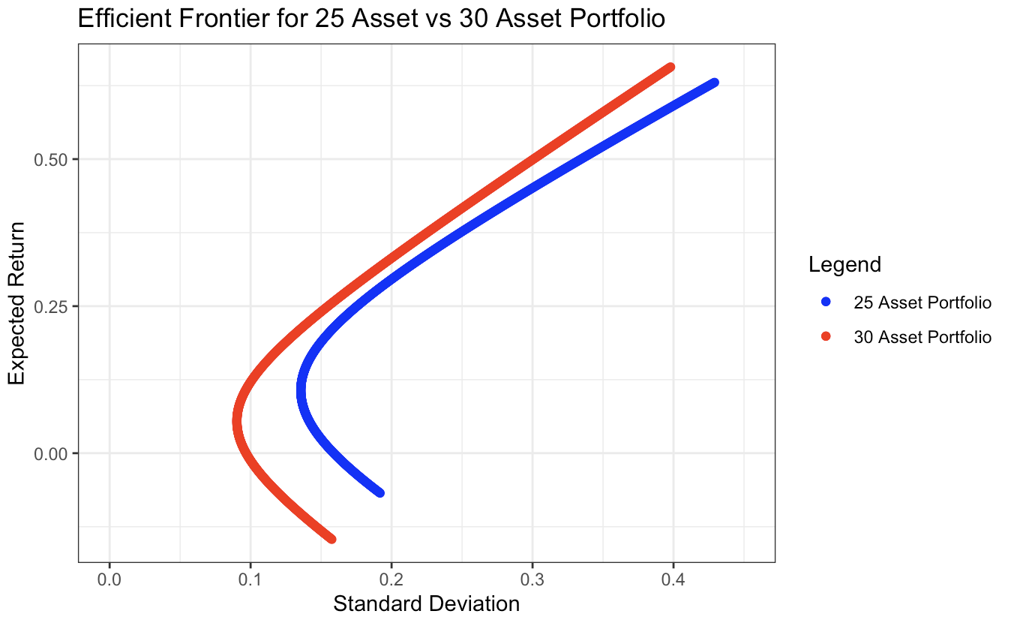
Figure 2.3 Comparison of Portfolio consisting of only TSE stocks vs TSE and HOSE stocks

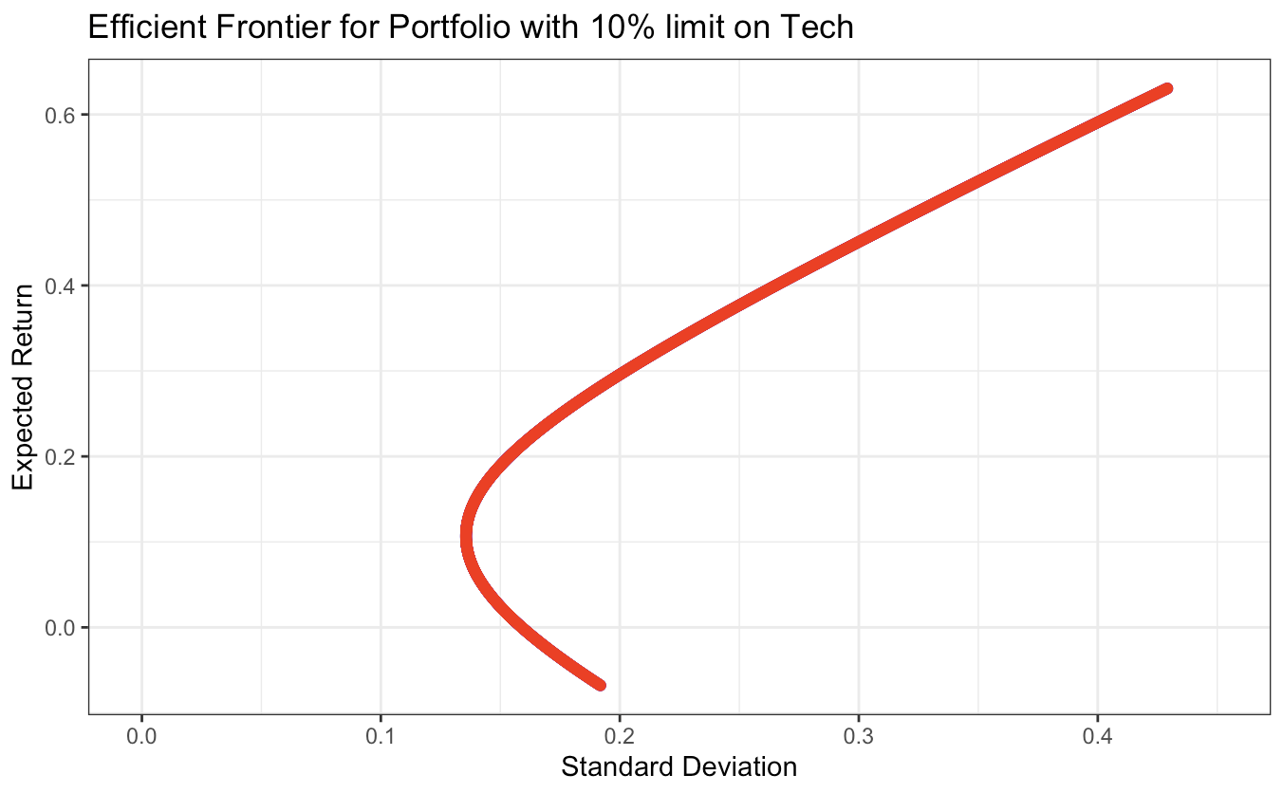
Figure 2.4 Efficient Frontier for 25 Asset TSE Shorts Sale Allowed with maximum weight of 10% in Tech.
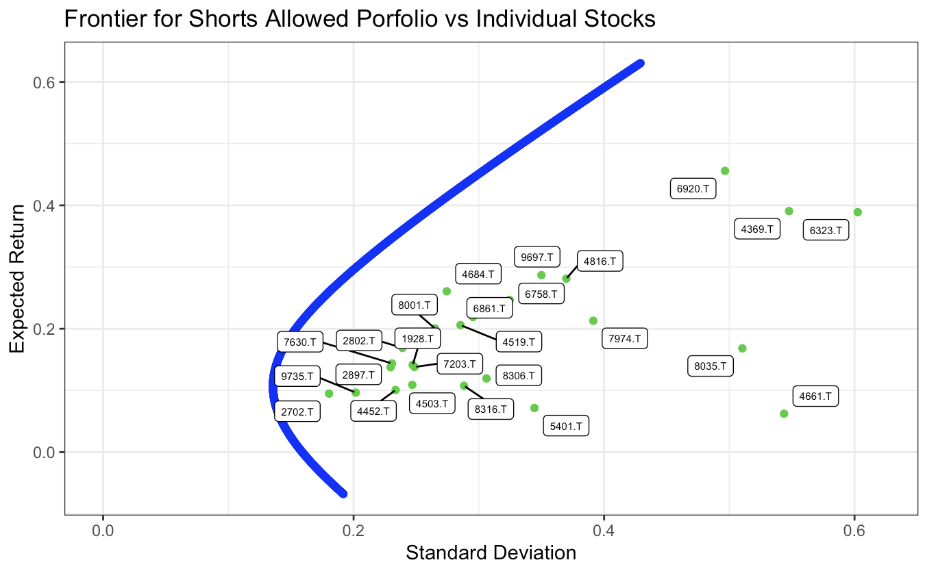
Figure 2.5 Labelled Plot of TSE Stock Codes Compared to Figure 2.2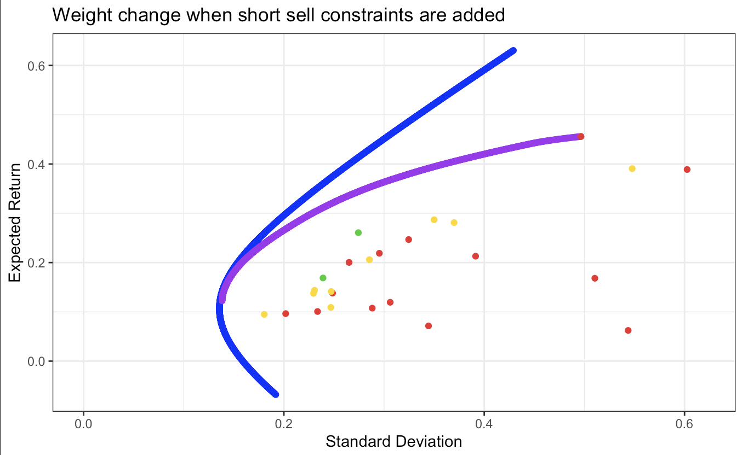
Figure 2.6 Weight Changes of TSE Stocks when Short Sale Restrictions are Applied (Green, Yellow and Red represent approximate increased, constant, and decreased weights) 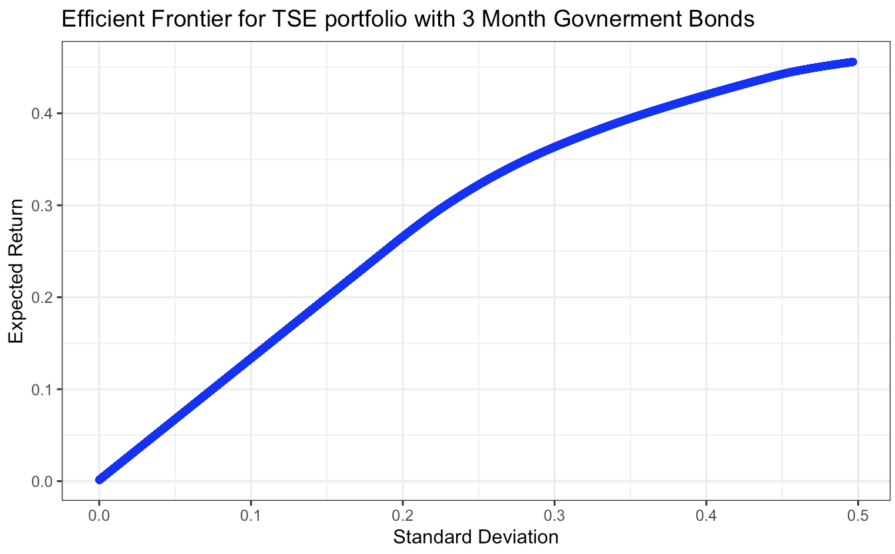
Figure 2.7 Efficient Frontier for Portfolio of 25 Japanese Stocks and 3 Month Japanese Government Bond
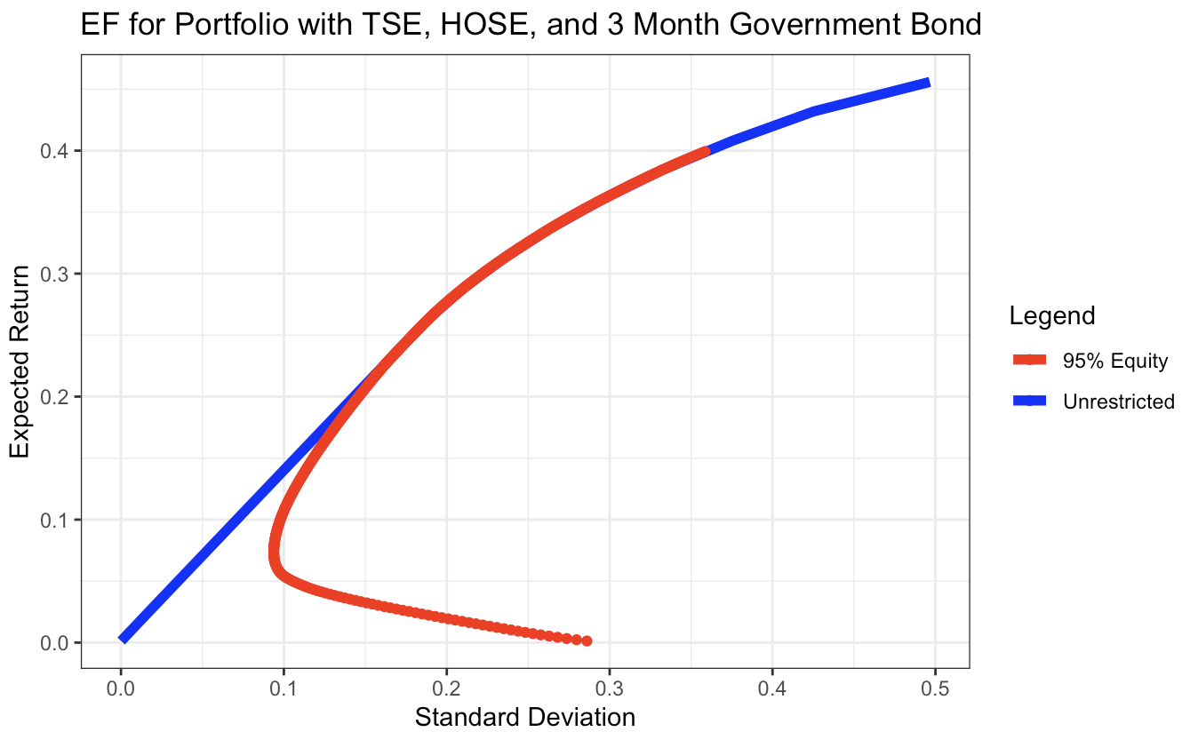
Figure 2.8 Efficient Frontier of 25 TSE, 5 HOSE and 3 Month Japanese Government Bond Portfolio

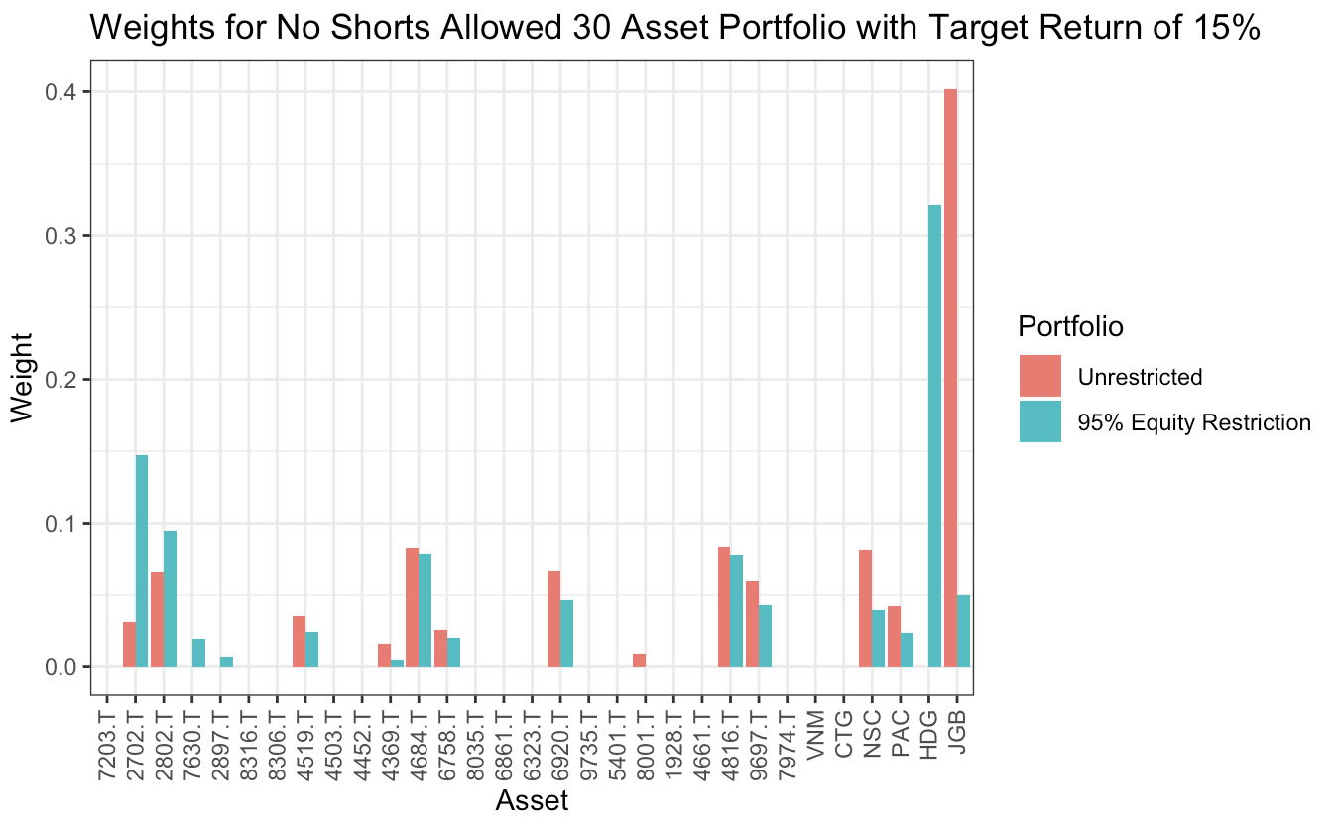
Figure 2.9 Weights for Portfolios with no short sells for 30 Asset and Bond Portfolio at target return of 15%
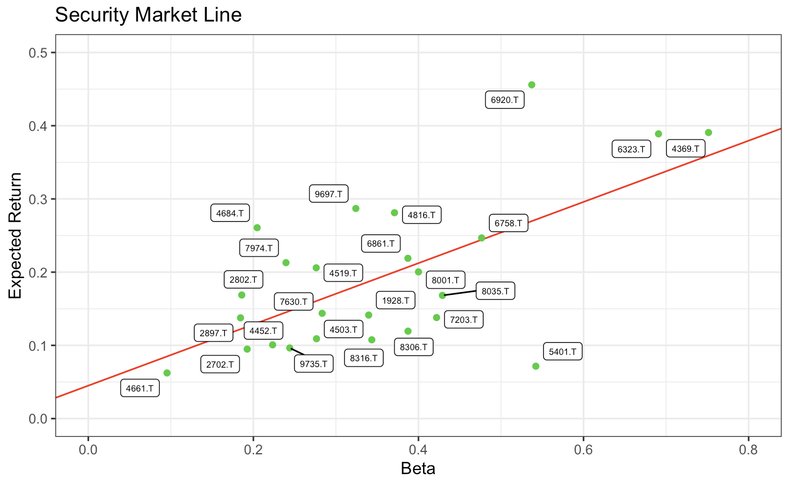
Figure 2.10 Labelled Security Market Line

Tables
Code | Company Name | Sector | Selection Reason
7203.T, | Toyota Motor Corporation | Consumer Discretionary | Recovery of Automotive Industry Following Covid, Established Brand Prestige
2702.T, | McDonald s Holdings Company Japan Ltd | Consumer Discretionary | Established Brand Prestige, Extremely Consistent Return,  Resilient Business Model
2802.T, | Ajinomoto Co Inc | Consumer Discretionary | Dominant player in the Japanese  food industry with a diversified portfolio  Healthy Short-Term Financials  Moderate Long-Term Financials
7630.T, | Ichibanya Co Ltd | Consumer Discretionary | Food company specialised in Japanese curry, one of the most of popular dishes in Japan with very strong brand presence
2897.T, | Nissin Foods Holdings Co Ltd | Consumer Staple | Established brand presence in convenient foods. Possesses a dominant global presence.
8316.T, | Sumitomo Mitsui Financial Group, Inc | Financial | One of the largest financial groups in Japan. Diversified financial services, including banking and insurance.
8306.T, | Mitsubishi UFJ Financial Group, Inc | Financial | International presence with a diverse range of financial products. Major company in the banking and financial services sector.
4519.T, | Chugai Pharmaceutical Co Ltd | Health Care | Pharmaceutical medicine for Ageing Japanese population in both long and short term, Extremely Healthy Financials
4503.T, | Astellas Pharma Inc | Health Care | Very Diverse product range compared to Chugai and hence a good auxiliary. Stronger focus on research and development of new health solutions
4452.T, | Kao Corp | Industrials | Diversified product portfolio, including personal care and cleaning products. Financial ratios are very similar to industry average, and is a safe pick for the Industrial Sector
4369.T, | Tri Chemical Laboratories Inc | Industrials | Potential for growth in industries such as manufacturing and technology.
4684.T, | Obic Co Ltd | Information/Technology | Provides IT solutions and services, including software development. Plays a role in Japan's growing technology sector.
6758.T, | Sony Group Corporation | Information/Technology | Diversified portfolio of electronic products and strong international presence in gaming and entertainment.
8035.T, | Tokyo Electron Limited | Information/Technology | Leading Company in semiconductor, one of Japan’s biggest industries. Semiconductor technology is being developed so industry still has the potential to grow.
6861.T, | Keyence Corporation | Information/Technology | Company specialised in the development and sale of automation and sensing equipment. High inelastic demand for products for industrial automation.
6323.T, | Rorze Corporation | Information/Technology | Similar Company to Keyence, Provided as an alternative and auxiliary to Keyence. Financials bad compared to the industry. Selected as an option to short.
6920.T, | Lasertec Corp | Information/Technology | Integration of semiconductor technology with electronic equipment. High Risk High Reward asset for more diversification in tech.
9735.T, | Secom Co Ltd | Information/Technology | Security Solutions Company, increased diversification in tech sector. Separate to other tech companies and the overall tech industry and won’t be affected by changes in the market as much.
5401.T, | Nippon Steel | Materials | Steel is a leading industry in Japan’s economy. Ratios are very similar to industry average
8001.T, | Itochu Corporation | Materials | Involved in textile and materials industry, also has machinery, energy and chemicals. Financial Ratios are very similar to industry standard
1928.T, | Sekisui House, Ltd | Real Estate | Construction Company included for diversification of portfolio. Japan’s high population density also means prices and hence returns of real estate have great potential
4661.T, | Oriental Land Co | Real Estate | Recovery of Tourism Industry indicates high potential, Healthy Financials
4816.T, | Toei Animation Co Ltd | Tele/Communication | Animation Company in growing industry. Very high historic returns. Ratios are around industry average
9697.T, | Capcom Co Ltd | Tele/Communications | Globally recognized video game developer and publisher. Established Brand Prestige in its market. Very high historic returns
7974.T | Nintendo Co Ltd | Tele/Communications | Iconic video game company with a diverse portfolio of popular franchises. Potential for growth as it expands to become a multimedia company. Established Prestige
VNM | VinaMilk | Consumer Staple | Leading dairy company in Vietnam. Potential for growth in the emerging market and increasing demand for dairy products. Increased diversification by having a company in consumer staple sector.
CTG | Viet Nam Joint Stock Commercial Bank | Financial | Positioned in the growing Vietnamese financial sector. Major bank in Vietnam with a diverse range of financial services.
NSC | National Seed Co | Industrials | Engaged in the production and distribution of seeds for farming. Increased diversification through unexplored sector of farming.
PAC | Dry Cell and Storage Battery Co | Industrials | Involved with the production of dry cells and batteries. Vietnam’s reliance on electricity will increase as Vietnam’s economy further develops.
HDG | Ha Do Group Co | Real Estate | Real estate development and construction in Vietnam. Positioned to target the Vietnam’s growing real estate market

Table 1.1 Annualised Returns and Risk of Each Asset and weights for Minimum-Variance Portfolios
Table 1.2 Asset Weights for portfolios with a target expected return of 15%
Table 1.3 Beta Coefficient of Japanese Stocks with the Japanese Markets and Breakdown of Risks

